**CHAPTER 1**

# INTRODUCTION

An embedded system is a special-purpose computer system that is designed to execute one or a few specific functions, often under time limitations. It's frequently found as part of a larger gadget that includes both hardware and mechanical components. A general-purpose computer, such as a personal computer, on the other hand, can do a wide range of functions depending on the programming. Embedded systems have become increasingly significant in today's world, as they manage many of the items we use on a daily basis. An embedded system is a set of computer hardware and software that is either fixed in capabilities or programmable and is built for a certain type of application device. Embedded systems can be found in a variety of places, including industrial machines, automobiles, medical equipment, cameras, household appliances, aeroplanes, vending machines, and toys (in addition to the more visible cellular phone and PDA). A programming interface is provided for programmable embedded systems, and embedded systems programming is a specialist vocation. Embedded Java and Windows XP Embedded, for example, are operating systems and language platforms specifically designed for the embedded market. The security paradigm has shifted from "investigation of occurrences" to "prevention of potentially catastrophic incidents" as a result of recent global events. Existing digital video surveillance systems simply provide the technology for capturing, storing, and distributing video, leaving danger detection to human operators alone. Surveillance video monitoring by humans is a time-consuming task. It's widely acknowledged that monitoring video feeds necessitates a higher level of visual focus than most other tasks. Specifically, vigilance, or the ability to pay attention and react to unusual events, is exceedingly difficult and prone to inaccuracy due to attention lapses.

**CHAPTER 2**

**OBJECTIVES**

* Remote Video Streaming: Enable live video streaming from the ESP32-CAM to a remote device over Wi-Fi, The core goal is to provide real-time video feed accessible from anywhere within the network range. This involves setting up the ESP32-CAM to capture video and stream it over the internet or local network to a smartphone, computer, or web application.
* Security: Use the video monitoring system to enhance security by surveilling critical areas, The system should monitor specific areas prone to unauthorized access or activities, thereby improving security measures. Continuous or scheduled monitoring can help deter potential intrusions and provide evidence if needed.

**CHAPTER 3**

# 

# LITERATURE SURVEY

The essence of surveillance lies in the vigilant monitoring and management of various activities and information, which serves as the cornerstone for identifying and mitigating potential threats across diverse scenarios and environments. This fundamental concept extends to multifaceted forms depending on the context and requirements, encompassing endeavors to prevent crime, ensure public safety, and combat the spread of diseases[1].

The integration of wireless communication modules and visual data collection systems in robotic platforms has garnered significant attention in recent years, facilitating remote control and monitoring capabilities across various applications. This section presents an overview of relevant literature exploring similar concepts and technologies. Wireless control mechanisms utilizing modules like the NodeMCU ESP8266 have become increasingly prevalent in robotics research[2].

The advancement of electronic intelligence technology has revolutionized the development of embedded systems, enabling the creation of versatile electronic products tailored to specific requirements. Embedded processors, in conjunction with various sensors, offer attributes like low power consumption, affordability, and system stability, making them indispensable in diverse applications such as industrial production, wearable devices, and robotics[3].

The concept of surveillance has undergone significant evolution, evolving from traditional community watch systems to modern CCTV and drone technologies. With advancements in artificial intelligence (AI), surveillance techniques have become more sophisticated, enabling enhanced monitoring and cloud-based surveillance solutions[4].

Surveillance plays a crucial role in monitoring dynamic environments and responding to emerging threats or challenges. Whether it involves tracking criminal activities or monitoring the spread of diseases, surveillance serves as a foundational mechanism for ensuring public safety and well-being[5].

The integration of remote-controlled machines into various applications has become increasingly prevalent, driven by advancements in wireless communication and microcontroller technology. These machines offer enhanced flexibility and functionality, enabling users to remotely manipulate their operation for diverse purposes[6].

**CHAPTER 4**

**METHODOLOGY**

* Hardware Setup: Assemble the necessary hardware components including the ESP32-CAM module, motor drivers, motors, wheels, chassis, battery. Connect the ESP32-CAM module to the motor drivers using jumper wires. Connect the motors to the motor drivers and attach the wheels to the motors.Power the system by connecting the battery to the ESP32-CAM module and the motor drivers.
* Programming: Program the ESP32-CAM module to control the movement of the robot and capture video and images. Use the Arduino IDE and ESP32-CAM library to write the code. Implement functions to control the motors, capture video and images, and send them to a remote server using Wi-Fi.
* Testing: Test the robot in different environments to ensure proper movement Check the quality and clarity of the captured video and images. Debug any issues and refine the code as necessary.
* Remote Access: Set up a server to receive the video and images captured by the robot. Enable remote access to the server using a smartphone or computer. Configure the system to allow users to view the surveillance footage in real-time.
* Interfacing Components: Interface the ESP32-CAM module with the motor driver (L298N) by connecting the necessary pins for controlling motor movement. Interface the ESP32-CAM module with the ARDUINO programmer to enable programming and communication with a computer through a USB port. Connect the gear motor to the L298N motor driver and provide power to control its speed and direction.
* Power Supply: Determine the power requirements for the ESP32-CAM module, motor driver, and gear motor. Provide a suitable power supply for each component to ensure proper operation without exceeding voltage and current ratings.
* Software Used: Utilize the Arduino IDE for programming the ESP32-CAM module. Install necessary libraries and packages for interfacing with motors and communication modules.

**CHAPTER 5**

**CIRCUIT DIAGRAM**

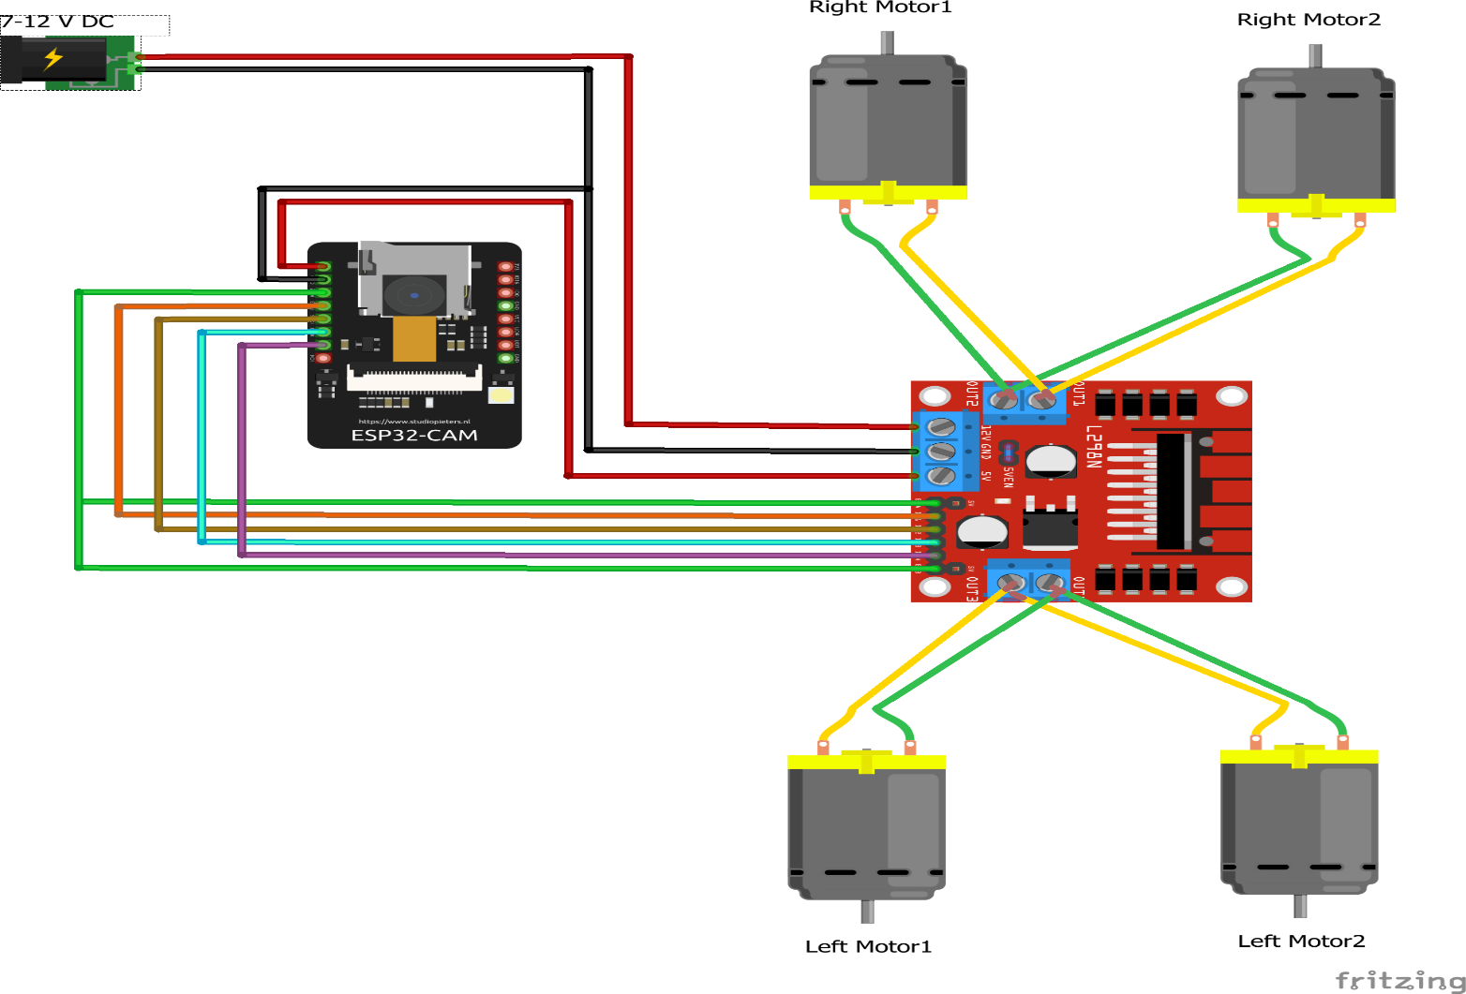

**CHAPTER 5**

**EXPECTED OUTCOME**

In this project, solar panel charge 12V DC battery continuously with the help of charge controller. When we turn on the switch, battery charge will inverted into AC with the help of inverter circuit and stepped the voltage from 12V DC to 230V AC. The design architecture of 60W UPS is compact & successful with few ripples in the output sine wave as verified by light. The switching between dc battery and ac light takes negligible time

i.e. less than the discharging time of the storage capacitor. The design also ensures no reverse current flow from battery to mains enhancing the safety features**.**

**CHAPTER 6**

**ADVANTAGES**

**ADVANTAGES AND APPLICATIONS**

* Easy Installation: A Solar UPS is easier to install than any other power generator. Also, it involves low maintenance cost.
* Economical: These systems are one time investment which consume lesser amount of power and are extremely affordable.
* High Productivity: These UPS systems generate maximum power output at low cost. Their power generation is much higher than their power consumption.

**APPLICATIONS**

Apart from homes and business houses, there has been an increase in the demand of Solar UPS systems for commercial and industrial applications such as:

* Educational Institutes
* Medical Facilities like MRI, CT and ultrasound scanners
* Shopping malls
* Corporate offices
* Security departments at work places

**CHAPTER 7**

**REFRENCE**

1. M.Asif, Sustainable energy options for Pakistan Renewable and Sustainable Energy Reviews, Volume 13, Issue 4, May 2009.
2. M. A. Ahmed, F. Ahmad and M. W. Akhtar, Estimation of Global and Diffuse Solar Radiation for Hyderabad, Sindh, Pakistan,

Published ISSN: 1814-8085 in Journal of Basic and Applied Sciences Vol. 5, No. 2, 73- 77, 2009.

1. K. Agbossou, M.L. Doumbiaa and A. Chériti, An improved maximum power point tracking method for photovoltaic systems, Volume

33, Issue 7, July 2008, Pages 1508-1516.

1. Product [Online]. Available: <http://www.affordable-solar.com/SunTech-Power-> STP270-24-Ub-1-24V-270W-PV-Module.htm.
2. Unpublished, Circuit Design Extended Runtime for Small UPS Machines, Figure.4 Form 41-7954 (3/99) DYNASTY VRLA USA**.**